

C U R R I C U L U M

Leo Machicao Barrionuevo

Francesco Soppelsa

Hernando Terrazas Silva

Iñigo Gómez Arribillaga

Enzo Vignolo Quiroz

Rafael Valenzuela

Calle Putxet, 40 1º · 08023 ·Barcelona

+34.93.3535690 · +34.626.386.282

xte-ad@xte-ad.com www.xte-ad.com

## [X.T]e·a+d

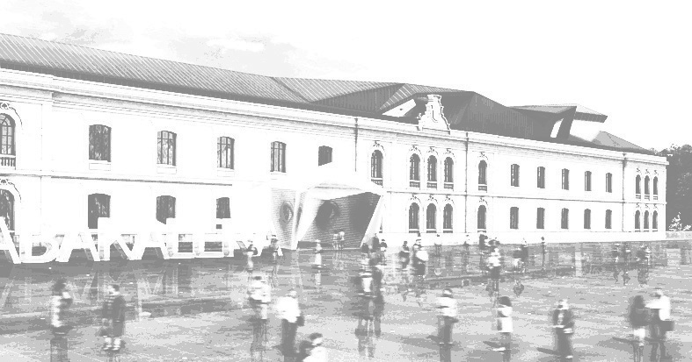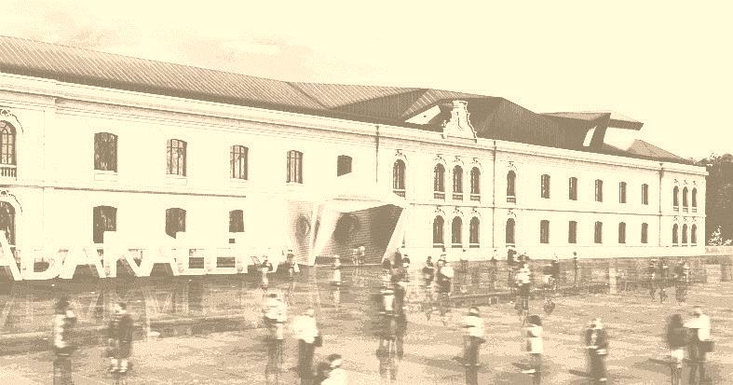

ALL CREATIVE TEAM AND EXPERIENCE OF SOLVENT TO YOUR SERVICE. RESPONSIBLE FOR OUR ENVIRONMENT.

### About Us

We are a multinational team of architects based in Barcelona and more than 15 years of professional experience in different countries. A team of architects with different pathways. Professional knowledgeable in all areas: technical, artistic, business and teaching.

A professional team with presence in Latin America and Europe, which is shaping their proposed architecture considering that there are many ways, many possibilities, many environments, many rules and many cultures consider ... but always with the people and their well-being as objective and motive.

### Professional field

With all the experience, individually and collectively, [XT] e • a + d develop our activities cover the whole field of design, from planning and urbanism, to the architectural and interior design, from the domain graphic arts as one of the pillars on which we support our creative work.

In addition, our real links with different countries and cultures allow us to enhance and adapt our proposals, coming on success at each site, every environment, every situation, every culture, every community, available resources, maintaining the essence of our projects with originality and creative resource.

### Filosofía de trabajo

Deeply recognize a place, whether a building, a parcel or a territory (in its people, topography, geography, climate, landscape, history and building industry locally available) is the beginning of the process that leads us to make an appropriate proposal and accurate . This approach allows us to make statements that go beyond purely aesthetic. It is what we understand as the essential beginning of a process that must be concluded, with certainty, on a proposal made in earnest and high quality.  
  
For us, the architecture goes and lives, affects our senses and, when you connect with their users, excited. With this vision, we can afford to combine concepts and freshness, elegance, warmth, CURRENT and QUIBBLE with others as effectiveness, sustainability, efficiency and functionality. The first to connect a place with our spirit, while the second support and enable the daily life and the various uses in place with sufficient comfort.

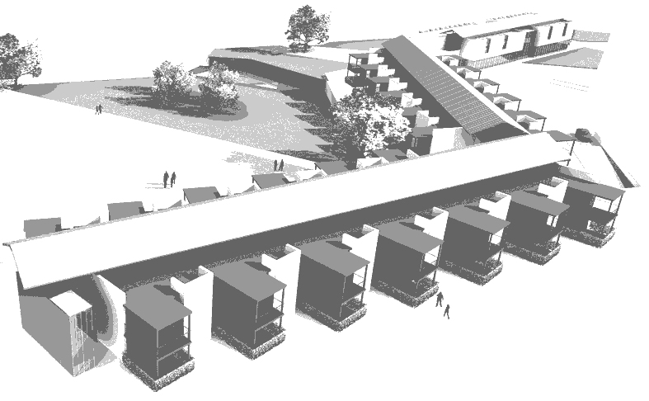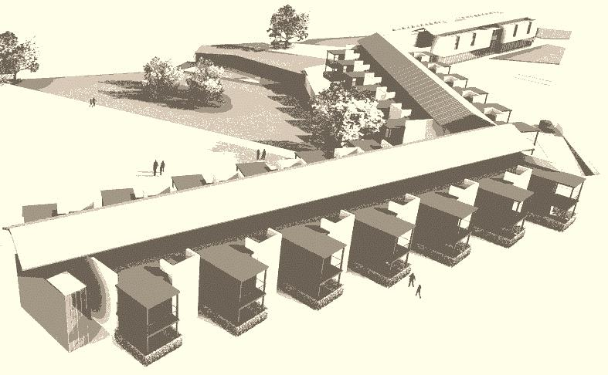

**Our experience**

Having worked in many cities and countries has revealed their resources as much as value, respect and admire their cultural and technical qualities. On the other hand, working with the latest technical resources available makes the most advanced tools to unleash your creativity.**[X.T]e·a+d TEAM**

## Leo Machicao Barrionuevo

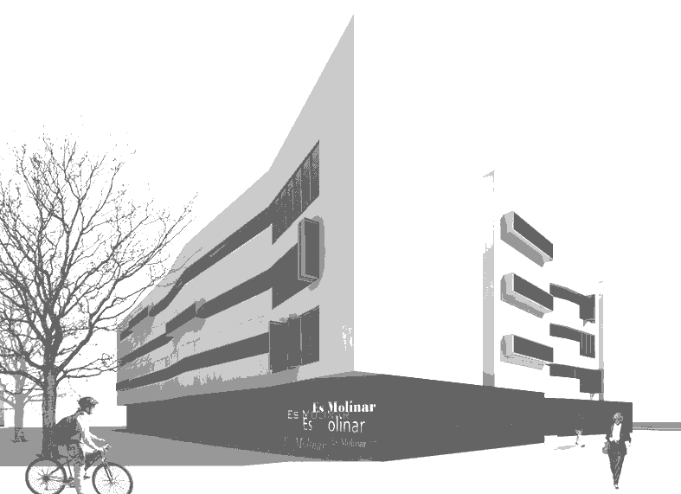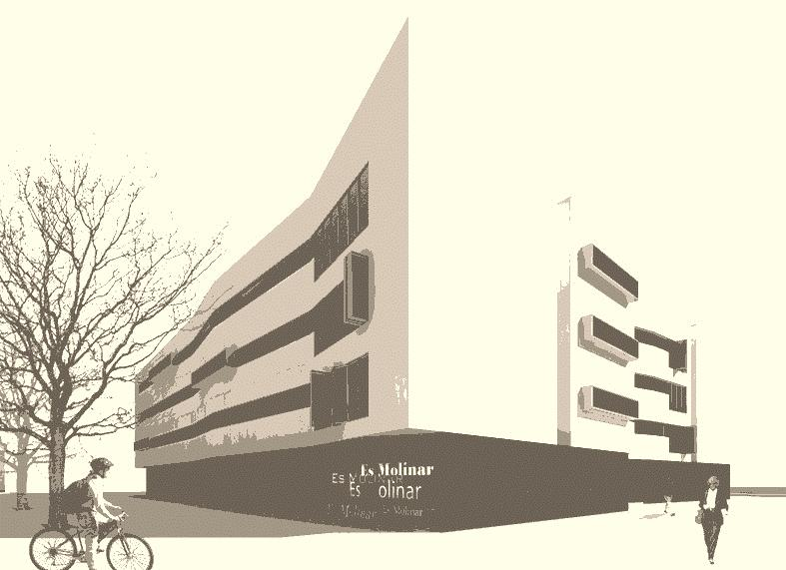

Lima, 1965.

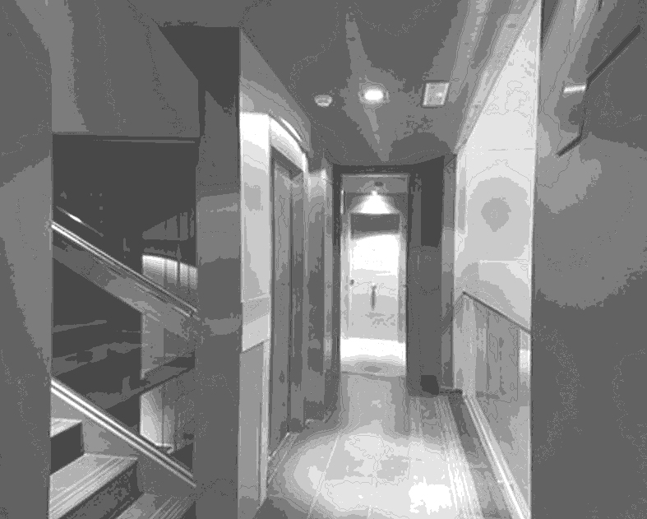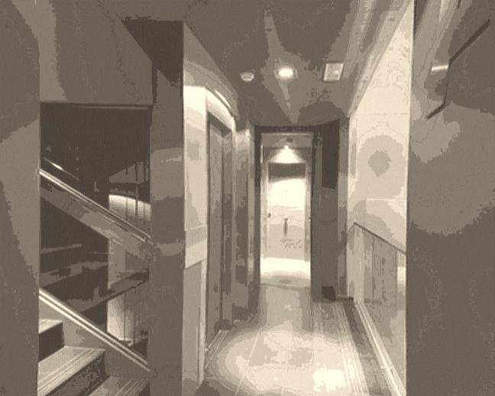

Architect (1992), FAUA-UNI. Perú.

PhD Studies (1999), ETSAB-UPC. Barcelona.

Master Studies (2000), ETSAB-UPC. Barcelona.

Lived in Barcelona since 1996.

He has collaborated with companies like: SOB Architects, Rius & Sisquella Architects, OMA Arquitectes Associats at Barcelona. MACH Asociados, CGN Architects and la Dirección Nacional de Turismo at Lima, among others.

Some of the projects that participated are as follows.

* CIRSA Headquartes. 2001. Terrassa. Spain.
* San Francisco Square. 2000. Cusco. Perú.
* Village Museum. 1999. Libia.
* Inmobiliaria Colonial Headquartes. 1998-2000. Barcelona. Spain.
* Ventanilla Hospital. 1998. Callao. Perú.
* SEDAPAL master Plan. 1995-1996. Lima. Perú.
* SEDAPAL Headquartes. 1995-1996. Lima. Perú.
* National library. Lima. Perú.
* Central Market at Ayacucho. Ayacucho. Perú.

## Francesco Soppelsa

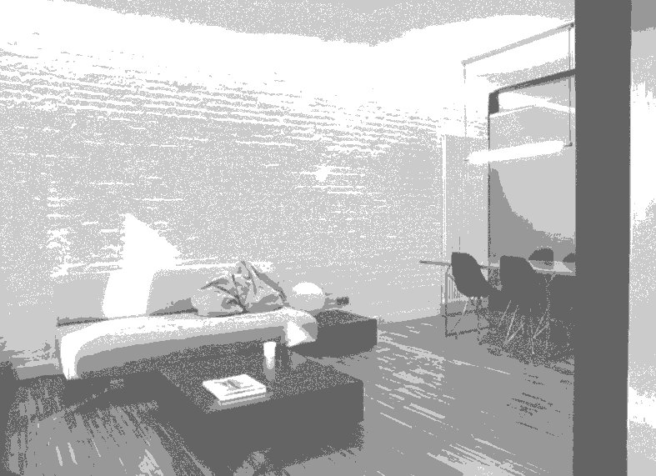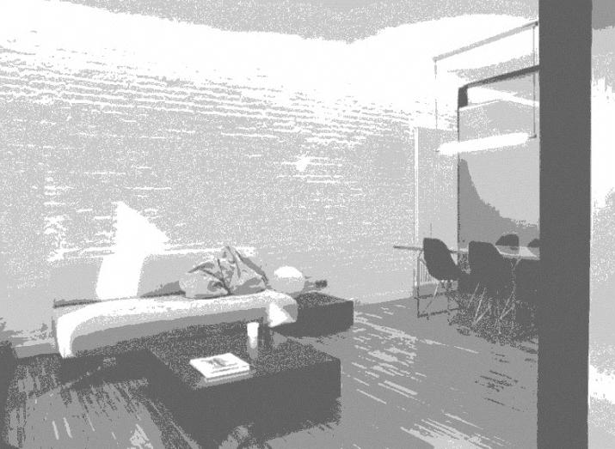

Vico Equense, Italia, 1967.

Architect (1997), Universitá degli Studi di Napoli Federico II

PhD Studies (2002), ETSAB-UPC. Barcelona.

Lived in Barcelona since 1999.

He has collaborated with companies like: Benedetto Gravagnuolo, FGP Studio, Enrico Sicignano at Naples, Italy and Octavio Mestre Architects at Barcelona, Spain.

Some of the projects that participated are as follows.

* Olivè Gumá Clinic 2009 Barcelona. Spain.
* Pineda de Mar House Beach 2007 Barcelona. Spain.
* Mutua Madrileña Headquarters 2007 Madrid. Spain.
* Apartment Building 2007 Sabadell. Spain.
* House at Coma-Ruga 2006 Tarragona. Spain.
* Mutua Madrileña Barcelona Headquarters 2006 Barcelona. Spain.
* Shoppping Mall Illa diagonal restoration 2003 Barcelona. Spain.

## Hernando Terrazas Silva

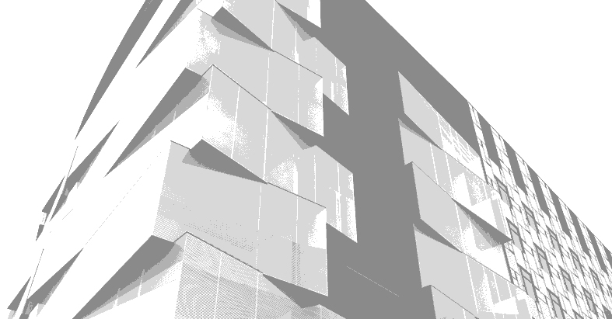

Chihuahua, México, 1976.

Architect (2000), Universidad Autónoma de Ciudad Juárez.

Master Studies (2003), Universitat Ramon Llull – La Salle. Barcelona.

Lived in Barcelona since 2002.

He has collaborated with companies like: Ferreiro & Terrazas Asociados and ArqCom del Norte at Ciudad Juárez, México. SMS Architects at El Paso, Texas, Estados Unidos. 3Scad (Autodesk), Jordi Bastús i Comellas Arquitecte and SOB Architects at Barcelona, Spain

Some of the projects that participated are as follows:

* Diputación Street development 2009 Barcelona, Spain.
* Residential complex Sybaris 2007 Tossa de Mar. Spain.
* Apartment building 2005 Caldes de Montbui. Spain.
* Residential complex Can Sebastianet 2004 Cànoves i Samalús. Spain.
* Clint Middle School Master Plan 2001 Clint. EEUU.
* White Sands Missile Range Training Center 2001 Alamogordo. EEUU.
* Urban Planning of Public Transportation 2000 Ciudad Juárez. México.
* Lajat Corporate 2000 Torreón. México.
* Las Américas Juárez Industrial Park 2000 Ciudad Juárez. México.

## Iñigo Gómez Arribillaga

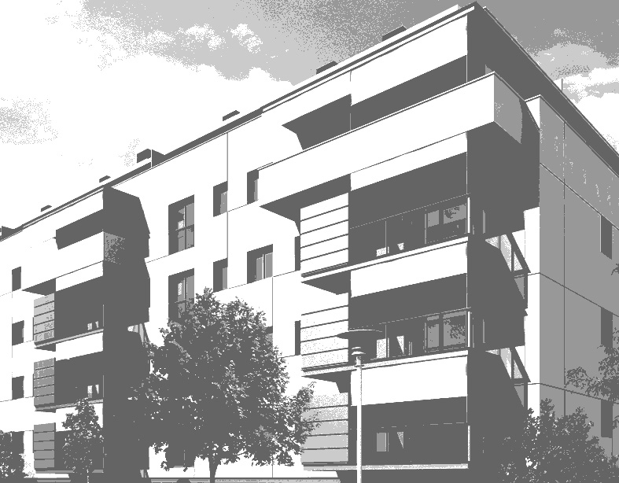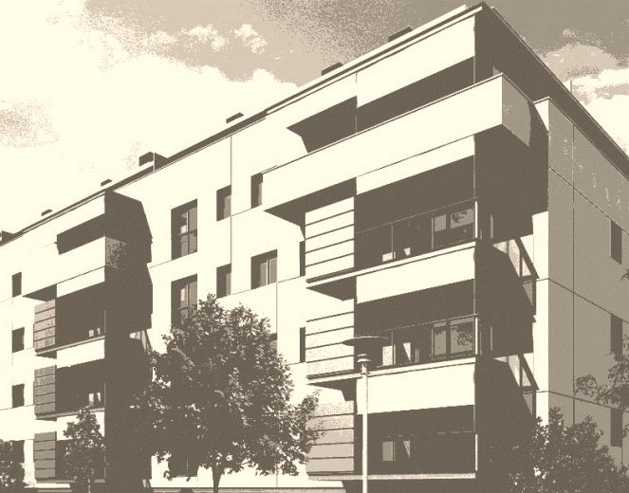

Andoain, Guipuzcoa, 1971.

Architect (1999), Universidad del País Vasco. San Sebastián.

Master Studies (2005), Universitat Ramon Llull – La Salle. Barcelona.

Lived in Barcelona since 2004.

He has collaborated with companies like: Samaniego + Beldarrain Architects, Samazuzu Architects at San Sebastián and SOB Architects at Barcelona.

Some of the projects that participated are as follows:

* Residential Complex 2006 Figueres. Spain.
* Residential Complex of 125 houses 2005 Benalmádena. Spain.
* Urban Plan of Zamatete 2004 Pasajes. Spain.
* Viñas de Valribera Winery 2003 Burgos. Spain.
* Faustino Winery 2000 Álava. Spain.

## Enzo Vignolo Quiroz

Santiago de Chile, 1967.

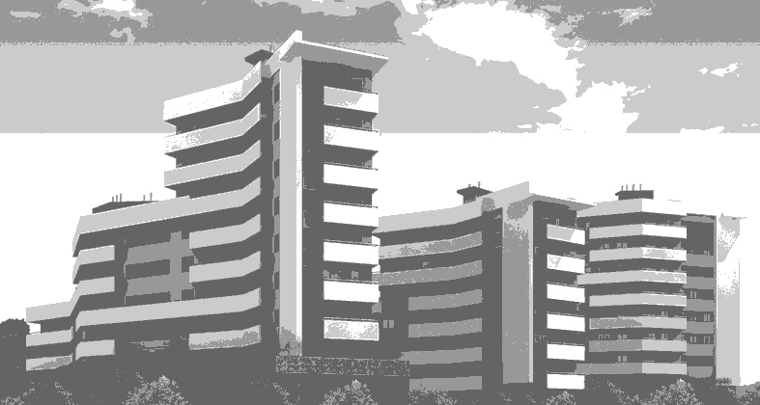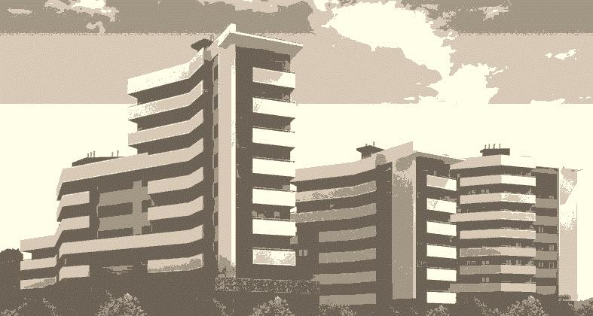

Architect (1993), Facultad de Arquitectura y Urbanismo de la Universidad Católica de Chile.

PhD Studies (1998), ETSAB-UPC. Barcelona

Lived in Barcelona since 1996.

He has collaborated with companies like: Estudio BL Architects at Santiago de Chile y en Ferrando+Vignolo, Arquitectura y Diseño, Octavio Mestre y GSA, Architects at Barcelona. And he teaches in the Master of Interior Design and Design Graduate Strategic Habitat at the Institute of Design Elisava Barcelona.

Some of the projects that participated are as follows:

* Apartment building 2008 Sant Feliu de Guìxols. Spain.
* Social dwelling building 2008 Vilanova i la Geltrú. Spain.
* Municipal Building of sports facilities 2006 Canet de Mar. Spain.
* Urban Planning at Curauma 1995 Valparaíso. Chile.
* Urban Planning at Santa Maria de Huechuraba 1994 Santiago de Chile. Chile.
* Mapocho Railway Station Building Restoration 1993 Santiago de Chile. Chile.

## Rafael Valenzuela Barón

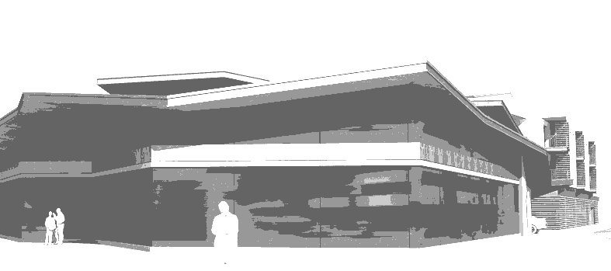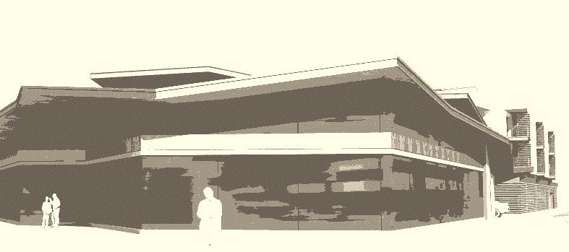

Bogotá, Colombia - 1974.

Architect (1997), Universidad Nacional de Colombia.

Graduate Studies (2001), Universidad de los Andes, Bogotá.

Master Studies (2003), Universitat Ramon Llull – La Salle. Barcelona.

Postgraduate Studies (2005), ETSAB-UPC. Barcelona.

Lived in Barcelona since 2002

He has collaborated with companies like: Instituto de Desarrollo Urbano, Zerofractal, Pedro Gómez & Cia., Conconcreto S.A. at Bogotá Colombia and SOB Architects at Barcelona.

Some of the projects that participated are as follows:

* Residential complex of 57 houses 2006 Figueres. Spain.
* Residential complex Sybaris 2007 Tossa de Mar. Spain.
* Residential complex Monastrell Llevant 2007 Vilafranca del Penedés. Spain.



**BARCELONA**